**Komunikat z zawodów strzeleckich**

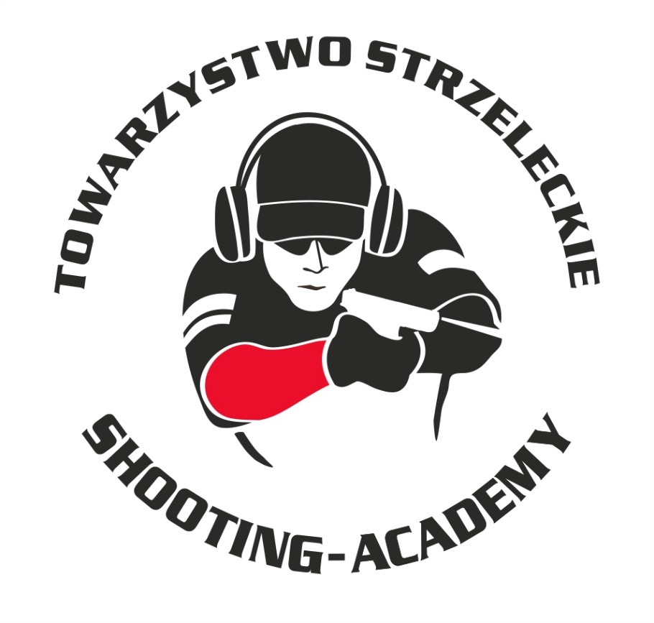

Organizator :

**Towarzystwo Strzeleckie Shooting-Academy**

Termin :

**15.09.2024 r.**

Miejsce :

**Strzelnica Shooting-Academy Parzęczew k/Łodzi**

# Karabin Centralnego Zapłonu 50m Open

| # zawodnik | klub |  | wynik |  |  |  |
| --- | --- | --- | --- | --- | --- | --- |
| |  |  |  |  | | --- | --- | --- | --- | | 1 | KONIECZNY Kamil | SHOOTING-ACADEMY Łódź | 92 | | 2 | WOŹNIAK Marcin | SHOOTING-ACADEMY Łódź | 90 | | 3 | LEŚNIEWSKI Marcin | SHOOTING-ACADEMY Łódź | 89 | | 4 | MEHLBERG Thomas | SHOOTING-ACADEMY Łódź | 88 | | 5 | ZIEMECKI Grzegorz | SHOOTING-ACADEMY Łódź | 85 | | 6 | GWOŹDZIŃSKI Marek | SHOOTING-ACADEMY Łódź | 84 | | 7 | MACIEJAK Paweł | SHOOTING-ACADEMY Łódź | 79 | | 8 | KRUSZYŃSKI Jan | SHOOTING-ACADEMY Łódź | 77 | | 9 | KRAWIEC Andrzej | SHOOTING-ACADEMY Łódź | 69 | | 10 | MITROWSKI Tomasz | SHOOTING-ACADEMY Łódź | 67 | | | | |  |  |  |

# Karabin Centralnego 50m Standard

| # | zawodnik | klub | wynik |
| --- | --- | --- | --- |
| 1 | MATUSIAK Jakub | SHOOTING-ACADEMY Łódź | 83 (2x10) |
| 2 | GUZIAK Michał | SHOOTING-ACADEMY Łódź | 83 (1x10) |
| 3 | MACIEJAK Paweł | SHOOTING-ACADEMY Łódź | 82 |
| 4 | PŁUCIENNIK Tomasz | SHOOTING-ACADEMY Łódź | 81 |
| 5 | ZIEMECKI Grzegorz | SHOOTING-ACADEMY Łódź | 79 |
| 6 | OLCZYK Krzysztof | SHOOTING-ACADEMY Łódź | 74 |
| 7 | PAWLAK Arkadiusz | SHOOTING-ACADEMY Łódź | 70 |
| 8 | WOŹNIAK Marcin | SHOOTING-ACADEMY Łódź | 65 |
| 9 | MITROWSKI Tomasz | SHOOTING-ACADEMY Łódź | 57 |
| 10 | DEMIDOW Konstanty | SHOOTING-ACADEMY Łódź | 56 |
| 11 | JACHOCKI Adam | SHOOTING-ACADEMY Łódź | 54 |
| 12 | GWOŹDZIŃSKI Marek | SHOOTING-ACADEMY Łódź | 35 |

# Pistolet Centralnego Zapłonu 25m

| # | zawodnik | klub | wynik |
| --- | --- | --- | --- |
| 1 | KONIECZNY Kamil | SHOOTING-ACADEMY Łódź | 95 |
| 2 | BIELIŃSKI Jarosław | SHOOTING-ACADEMY Łódź | 89 |
| 3 | WOŹNIAK Marcin | SHOOTING-ACADEMY Łódź | 87 |
| 4 | JACHOCKI Adam | SHOOTING-ACADEMY Łódź | 78 |
| 5 | ZIEMECKI Grzegorz | SHOOTING-ACADEMY Łódź | 72 (1x11, 2x10) |
| 6 | MITROWSKI Tomasz | SHOOTING-ACADEMY Łódź | 72 (1x11, 1x10) |
| 7 | OLCZYK Krzysztof | SHOOTING-ACADEMY Łódź | 71 |
| 8 | DEMIDOW Konstanty | SHOOTING-ACADEMY Łódź | 69 (2x9, 2x8) |
| 9 | KRUSZYŃSKI Jan | SHOOTING-ACADEMY Łódź | 69 (2x9, 1x8) |
| 10 | PAWLAK Arkadiusz | SHOOTING-ACADEMY Łódź | 67 |
| 11 | MACIEJAK Paweł | SHOOTING-ACADEMY Łódź | 65 |
| 12 | KRAWIEC Andrzej | SHOOTING-ACADEMY Łódź | 64 |
| 13 | LEŚNIEWSKI Marcin | SHOOTING-ACADEMY Łódź | 60 |
| 14 | PŁUCIENNIK Tomasz | SHOOTING-ACADEMY Łódź | 56 |
| 15 | MATUSIAK Jakub | SHOOTING-ACADEMY Łódź | 55 |
| 16 | GUZIAK Michał | SHOOTING-ACADEMY Łódź | 53 |
| 17 | SOWIŃSKI Mateusz | SHOOTING-ACADEMY Łódź | 50 |
| 18 | MEHLBERG Thomas | SHOOTING-ACADEMY Łódź | 48 |
| 19 | GWOŹDZIŃSKI Marek | SHOOTING-ACADEMY Łódź | 47 |
| 20 | FTOMOV Seweryn | SHOOTING-ACADEMY Łódź | 42 |

# Pistolet Bocznego Zapłonu 25m

| # | zawodnik | klub | wynik |
| --- | --- | --- | --- |
| 1 | KONIECZNY Kamil | SHOOTING-ACADEMY Łódź | 88 |
| 2 | KRAWIEC Andrzej | SHOOTING-ACADEMY Łódź | 75 |
| 3 | WOŹNIAK Marcin | SHOOTING-ACADEMY Łódź | 61 |
| 4 | ZIEMECKI Grzegorz | SHOOTING-ACADEMY Łódź | 60 |

# StalLufka Pistolet Centralnego Zapłonu

| # | zawodnik | klub | wynik |
| --- | --- | --- | --- |
| 1 | BIELIŃSKI Jarosław | SHOOTING-ACADEMY Łódź | 18,45 |
| 2 | WOŹNIAK Marcin | SHOOTING-ACADEMY Łódź | 19,46 |
| 3 | LEŚNIEWSKI Marcin | SHOOTING-ACADEMY Łódź | 26,37 |
| 4 | MATUSIAK Jakub | SHOOTING-ACADEMY Łódź | 31,29 |
| 5 | GUZIAK Michał | SHOOTING-ACADEMY Łódź | 31,96 |
| 6 | OLCZYK Krzysztof | SHOOTING-ACADEMY Łódź | 32,62 |
| 7 | PAWLAK Arkadiusz | SHOOTING-ACADEMY Łódź | 34,67 |
| 8 | JACHOCKI Adam | SHOOTING-ACADEMY Łódź | 36,11 |
| 9 | MEHLBERG Thomas | SHOOTING-ACADEMY Łódź | 38,96 |
| 10 | KRUSZYŃSKI Jan | SHOOTING-ACADEMY Łódź | 39,71 |
| 11 | DEMIDOW Konstanty | SHOOTING-ACADEMY Łódź | 59,20 |
| 12 | ZIEMECKI Grzegorz | SHOOTING-ACADEMY Łódź | 108,21 |

# StalLufka Karabinek PCC

| # | zawodnik | klub | wynik |
| --- | --- | --- | --- |
| 1 | BIELIŃSKI Jarosław | SHOOTING-ACADEMY Łódź | 11,98 |

# Strzelba Dynamiczna 10 strzałów Manual

| # | zawodnik | klub | wynik |
| --- | --- | --- | --- |
| 1 | MATUSIAK Jakub | SHOOTING-ACADEMY Łódź | 16,90 |
| 2 | ZIEMECKI Grzegorz | SHOOTING-ACADEMY Łódź | 17,62 |
| 3 | PAWLAK Arkadiusz | SHOOTING-ACADEMY Łódź | 32,12 |
| 4 | WOŹNIAK Marcin | SHOOTING-ACADEMY Łódź | 32,62 |
| 5 | DEMIDOW Konstanty | SHOOTING-ACADEMY Łódź | 37,71 |
|  |  |  |  |
| 6 | GUZIAK Michał | SHOOTING-ACADEMY Łódź | 44,32 |
| 7 | FTOMOV Seweryn | SHOOTING-ACADEMY Łódź | 44,84 |
| 8 | KRUSZYŃSKI Jan | SHOOTING-ACADEMY Łódź | 49,14 |
| 9 | SOWIŃSKI Mateusz | SHOOTING-ACADEMY Łódź | 49,15 |
| 10 | MACIEJAK Paweł | SHOOTING-ACADEMY Łódź | 57,56 |
| 11 | PŁUCIENNIK Tomasz | SHOOTING-ACADEMY Łódź | 59,26 |
| 12 | KRAWIEC Andrzej | SHOOTING-ACADEMY Łódź | 68,02 |
| 13 | JACHOCKI Adam | SHOOTING-ACADEMY Łódź | 79,95 |
| 14 | GWOŹDZIŃSKI Marek | SHOOTING-ACADEMY Łódź | 103,60 |
| 15 | LEŚNIEWSKI Marcin | SHOOTING-ACADEMY Łódź | 108,00 |

# Strzelba Dynamiczna 10 strzałów Semi-Auto

| # | zawodnik | klub | wynik |
| --- | --- | --- | --- |
| 1 | ZIEMECKI Grzegorz | SHOOTING-ACADEMY Łódź | 10,39 |
| 2 | WOŹNIAK Marcin | SHOOTING-ACADEMY Łódź | 13,87 |
| 3 | OLCZYK Krzysztof | SHOOTING-ACADEMY Łódź | 17,49 |
| 4 | MEHLBERG Thomas | SHOOTING-ACADEMY Łódź | 22,40 |
| 5 | KONIECZNY Kamil | SHOOTING-ACADEMY Łódź | 27,56 |

**Obsada sędziowska :**

1. BIELIŃSKI Jarosław – Sędzia na torze/ Sędzia główny zawodów
2. SUZIN Nikodem – Sędzia na torze/ Przewodniczący RTI

*Przewodniczący RTI*

*SUZIN Nikodem*