**Komunikat z zawodów strzeleckich**

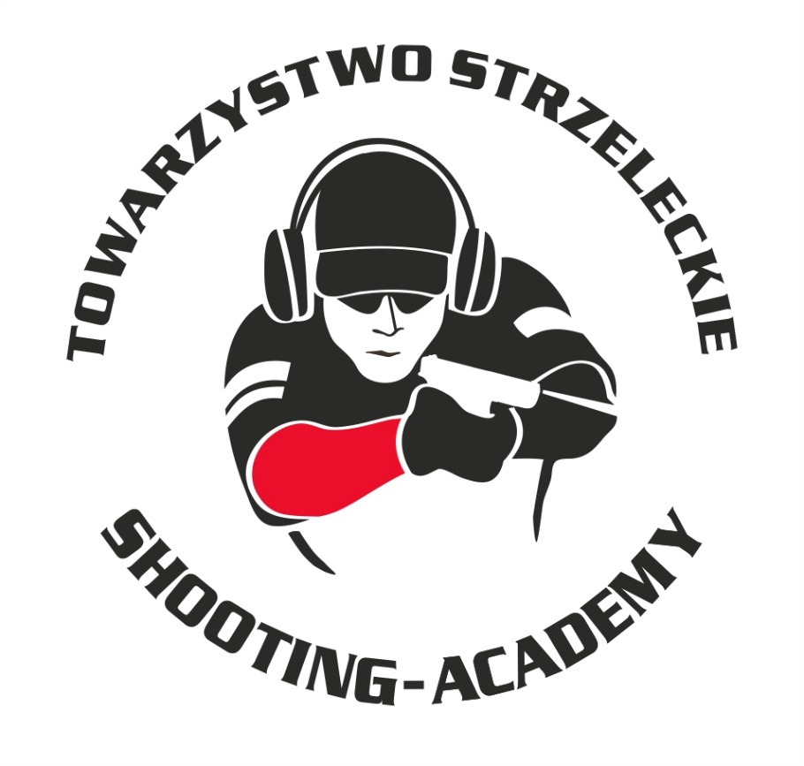

Organizator :

**Towarzystwo Strzeleckie Shooting-Academy**

Termin :

**13.10.2024 r.**

Miejsce :

**Strzelnica Shooting-Academy Parzęczew k/Łodzi**

# Karabin Bocznego Zapłonu 50m Standard

| # zawodnik | klub |  | wynik |  |  |  |
| --- | --- | --- | --- | --- | --- | --- |
| |  |  |  |  | | --- | --- | --- | --- | | 1 | MARCINKOWSKI Łukasz | SHOOTING-ACADEMY Łódź | 73 | | | | |  |  |  |

# Karabin Bocznego Zapłonu 50m Open

| # zawodnik | klub |  | wynik |  |  |  |
| --- | --- | --- | --- | --- | --- | --- |
| |  |  |  |  | | --- | --- | --- | --- | | 1 | SZARSKI Jacek | SHOOTING-ACADEMY Łódź | 96 | | 2 | MARCINKOWSKI Łukasz | SHOOTING-ACADEMY Łódź | 78 | | 3 | MARCINKOWSKA Monika | SHOOTING-ACADEMY Łódź | 65 | | | | |  |  |  |

# Karabin Centralnego Zapłonu 50m Open

| # zawodnik | klub |  | wynik |  |  |  |
| --- | --- | --- | --- | --- | --- | --- |
| |  |  |  |  | | --- | --- | --- | --- | | 1 | SZARSKI Jacek | SHOOTING-ACADEMY Łódź | 94 | | 2 | MIELCZAREK Michał | SHOOTING-ACADEMY Łódź | 92 | | 3 | MACIEJAK Paweł | SHOOTING-ACADEMY Łódź | 87 | | 4 | MARCINKOWSKI Łukasz | SHOOTING-ACADEMY Łódź | 83 | | 5 | BIELIŃSKI Artur | SHOOTING-ACADEMY Łódź | 79 | | 6 | HEMKA Krzysztof | SHOOTING-ACADEMY Łódź | 76 (1x11) | | 7 | MARCINKOWSKA Monika | SHOOTING-ACADEMY Łódź | 76 (0x11) | | 8 | MEHLBERG Jarosław | SHOOTING-ACADEMY Łódź | 64 | | | | |  |  |  |

# Karabin Centralnego 50m Standard

| # | zawodnik | klub | wynik |
| --- | --- | --- | --- |
| 1 | MATUSIAK Jakub | SHOOTING-ACADEMY Łódź | 90 |
| 2 | MATUSIAK Michał | SHOOTING-ACADEMY Łódź | 88 |
| 3 | MIELCZAREK Michał | SHOOTING-ACADEMY Łódź | 78 |
| 4 | MARCINKOWSKA Monika | SHOOTING-ACADEMY Łódź | 75 (3x9) |
| 5 | KRUSZYŃSKI Jan | SHOOTING-ACADEMY Łódź | 75 (1x9) |
| 6 | DAWIDOW Konstanty | SHOOTING-ACADEMY Łódź | 72 |
| 7 | MACIEJAK Paweł | SHOOTING-ACADEMY Łódź | 69 |
| 8 | OLCZYK Krzysztof | SHOOTING-ACADEMY Łódź | 65 |
| 9 | MARCINKOWSKI Łukasz | SHOOTING-ACADEMY Łódź | 61 |
| 10 | PAWLAK Arkadiusz | SHOOTING-ACADEMY Łódź | 57 (2x9) |
| 11 | MARCINKOWSKA Monika | SHOOTING-ACADEMY Łódź | 57 (1x9) |
| 12 | JACHOCKI Adam | SHOOTING-ACADEMY Łódź | 55 |
| 13 | BIELIŃSKI Artur | SHOOTING-ACADEMY Łódź | 54 |
| 14 | HAMKA Krzysztof | SHOOTING-ACADEMY Łódź | 47 |
| 15 | STARZYŃSKI Piotr | SHOOTING-ACADEMY Łódź | 6 |
| 16 | SUZIN Nikodem | SHOOTING-ACADEMY Łódź | 3 |

# Pistolet Centralnego Zapłonu 25m

| # | zawodnik | klub | wynik |
| --- | --- | --- | --- |
| 1 | BIELIŃSKI Jarosław | SHOOTING-ACADEMY Łódź | 94 |
| 2 | JACHOCKI Adam | SHOOTING-ACADEMY Łódź | 88 |
| 3 | SOBCZAK Daniel | SHOOTING-ACADEMY Łódź | 84 |
| 4 | MIELCZAREK Michał | SHOOTING-ACADEMY Łódź | 81 |
| 5 | KLUCZKOWSKI Konrad | KRUK Łask | 79 |
| 6 | SZARSKI Jacek | SHOOTING-ACADEMY Łódź | 76 |
| 7 | PAWLAK Arkadiusz | SHOOTING-ACADEMY Łódź | 72 (1x11) |
| 8 | BIELIŃSKI Artur | SHOOTING-ACADEMY Łódź | 72 (0x11) |
| 9 | HEMKA Krzysztof | SHOOTING-ACADEMY Łódź | 71 |
| 10 | STARZYŃSKI Piotr | SHOOTING-ACADEMY Łódź | 69 (3x9) |
| 11 | OLCZYK Krzysztof | SHOOTING-ACADEMY Łódź | 69 (1x9) |
| 12 | DAWIDOW Konstanty | SHOOTING-ACADEMY Łódź | 66 (1x11) |
| 13 | KIEMONA Jerzy | SHOOTING-ACADEMY Łódź | 66 (0x11) |
| 14 | MEHLBERG Jarosław | SHOOTING-ACADEMY Łódź | 64 |
| 15 | KRUSZYŃSKI Jan | SHOOTING-ACADEMY Łódź | 60 |
| 16 | KELM Maciej | SHOOTING-ACADEMY Łódź | 57 |
| 17 | FTOMOV Seweryn | SHOOTING-ACADEMY Łódź | 49 |
| 18 | KELM Robert | SHOOTING-ACADEMY Łódź | 48 |
| 19 | MATUSIAK Michał | SHOOTING-ACADEMY Łódź | 44 |
| 20 | MATUSIAK Jakub | SHOOTING-ACADEMY Łódź | 42 |
| 21 | Maciejak Paweł | SHOOTING-ACADEMY Łódź | 41 |
| 22 | KELM Joanna | SHOOTING-ACADEMY Łódź | 40 |
| 23 | MARCINKOWSKI Łukasz | SHOOTING-ACADEMY Łódź | 30 |
| 24 | MARCINKOWSKA Monika | SHOOTING-ACADEMY Łódź | 25 |
| 25 | SUZIN Nikodem | SHOOTING-ACADEMY Łódź | 9 |
|  |  |  |  |

# Pistolet Bocznego Zapłonu 25m

| # | zawodnik | klub | wynik |
| --- | --- | --- | --- |
| 1 | BIELIŃSKI Jarosław | SHOOTING-ACADEMY Łódź | 80 |
| 2 | SZARSKI Jacek | SHOOTING-ACADEMY Łódź | 70 |
| 3 | HEMKA Krzysztof | SHOOTING-ACADEMY Łódź | 42 |

# StalLufka Pistolet Centralnego Zapłonu

| # | zawodnik | klub | wynik |
| --- | --- | --- | --- |
| 1 | BIELIŃSKI Jarosław | SHOOTING-ACADEMY Łódź | 18,78 |
| 2 | BIELIŃSKI Artur | SHOOTING-ACADEMY Łódź | 19,50 |
| 3 | MIELCZAREK Michał | SHOOTING-ACADEMY Łódź | 25,54 |
| 4 | HEMKA Krzysztof | SHOOTING-ACADEMY Łódź | 26,51 |
| 5 | SOBCZAK Daniel | SHOOTING-ACADEMY Łódź | 27,52 |
| 6 | KLUCZKOWSKI Konrad | KRUK Łask | 28,29 |
| 7 | STARZYŃSKI Piotr | SHOOTING-ACADEMY Łódź | 28,60 |
| 8 | OLCZYK Krzysztof | SHOOTING-ACADEMY Łódź | 29,61 |
| 9 | MARCINKOWSKI Łukasz | SHOOTING-ACADEMY Łódź | 31,24 |
| 10 | KRUSZYŃSKI Jan | SHOOTING-ACADEMY Łódź | 32,28 |
| 11 | DAWIDOW Konstanty | SHOOTING-ACADEMY Łódź | 33,70 |
| 12 | MATUSIAK Michał | SHOOTING-ACADEMY Łódź | 36,84 |
| 13 | MEHLBERG Jarosław | SHOOTING-ACADEMY Łódź | 37,44 |
| 14 | JACHOCKI Adam | SHOOTING-ACADEMY Łódź | 39,23 |
| 15 | MATUSIAK Jakub | SHOOTING-ACADEMY Łódź | 40,47 |
| 16 | PAWLAK Arkadiusz | SHOOTING-ACADEMY Łódź | 49,44 |
| 17 | MARCINKOWSKA Monika | SHOOTING-ACADEMY Łódź | 83,66 |

# StalLufka Karabinek PCC

| # | zawodnik | klub | wynik |
| --- | --- | --- | --- |
| 1 | BIELIŃSKI Jarosław | SHOOTING-ACADEMY Łódź | 11,31 |
| 2 | HEMKA Krzysztof | SHOOTING-ACADEMY Łódź | 19,57 |

# Strzelba Dynamiczna 10 strzałów Manual

| # | zawodnik | klub | wynik |
| --- | --- | --- | --- |
| 1 | SZARSKI Jacek | SHOOTING-ACADEMY Łódź | 15,30 |
| 2 | MATUSIAK Jakub | SHOOTING-ACADEMY Łódź | 19,99 |
| 3 | MATUSIAK Michał | SHOOTING-ACADEMY Łódź | 20,97 |
| 4 | MARCINKOWSKI Łukasz | SHOOTING-ACADEMY Łódź | 24,07 |
| 5 | MIELCZAREK Michał | SHOOTING-ACADEMY Łódź | 24,62 |
| 6 | PAWLAK Arkadiusz | SHOOTING-ACADEMY Łódź | 28,42 |
| 7 | MEHLBERG Jarosław | SHOOTING-ACADEMY Łódź | 33,77 |
| 8 | DAWIDOW Konstanty | SHOOTING-ACADEMY Łódź | 34,03 |
| 9 | FTOMOV Seweryn | SHOOTING-ACADEMY Łódź | 40,05 |
| 10 | JACHOCKI Adam | SHOOTING-ACADEMY Łódź | 42,87 |
| 11 | MARCINKOWSKA Monika | SHOOTING-ACADEMY Łódź | 43,07 |
| 12 | BIELIŃSKI Artur | SHOOTING-ACADEMY Łódź | 44,49 |
| 13 | KLUCZKOWSKI Konrad | KRUK Łask | 45,54 |
| 14 | STARZYŃSKI Piotr | SHOOTING-ACADEMY Łódź | 46,02 |
| 15 | KRUSZYŃSKI Jan | SHOOTING-ACADEMY Łódź | 49,83 |
| 16 | MACIEJAK Paweł | SHOOTING-ACADEMY Łódź | 53,03 |
| 17 | HEMKA Krzysztof | SHOOTING-ACADEMY Łódź | 74,90 |

# Strzelba Dynamiczna 10 strzałów Semi-Auto

| # | zawodnik | klub | wynik |
| --- | --- | --- | --- |
| 1 | SZARSKI Jacek | SHOOTING-ACADEMY Łódź | 11,59 |
| 2 | MARCINKOWSKI Łukasz | SHOOTING-ACADEMY Łódź | 19,38 |
| 3 | BIELIŃSKI Artur | SHOOTING-ACADEMY Łódź | 31,27 |
| 4 | OLCZYK Krzysztof | SHOOTING-ACADEMY Łódź | 35,91 |
| 5 | MARCINKOWSKA Monika | SHOOTING-ACADEMY Łódź | 88,84 |
| 6 | SUZIN Nikodem | SHOOTING-ACADEMY Łódź | 90,00 |
|  |  |  |  |

**Obsada sędziowska :**

1. BIELIŃSKI Jarosław – Sędzia na torze/ Sędzia główny zawodów
2. SUZIN Nikodem – Sędzia na torze/ Przewodniczący RTI

*Przewodniczący RTI*

*SUZIN Nikodem*